**Health Tracker System**

***Abstract***

Health tracker system is a web application system that can be used to check or monitor one’s own health based on the food consumption and the exercise a person does on the daily basis. The website has the information about the calories of different food, the number of calories that burn during the exercises. By all this information user can track the weight loss or weight gain in a month or given amount of time. The website has BMI (body mass index) calculator to find whether overweight or underweight. There are three types of users: admin, dietitians/doctors and normal users.

Further options the website provides for the users are:

* Health tips – website is frequently updated with health tips. Tips can be organised according to the user’s selection and their needs, such as yoga, healthy foods, tips to reduce weight etc
* Dietitians can provide their clinics details with their address.
* Users can make appointment online according to availability of dietitians.
* Dietitians can provide a course or a diet plan. Users can enrol in these diet plans. They can provide video lectures and other materials.

Three types of users are: -

**Admin**

who controls the website. Give authorisation to verified dietitian. Can add information about.

**Dietitians/Doctors**

can add information about foods and its calories, can add diet plans, can provide, health tips, can provide their location of clinics or hospitals and their appointment times. They must provide a valid certificate to get verified by the admin. They can be rated by the users.

**Normal users**

there will be a registration form for the user. Their BMI is calculated and gets whether he/she is obese or underweight. User can provide a target weight to be reduced or gained within a period of time. They can enrol in a diet plan provided by the verified dietitian. They can view health tips. They can make an appointment if its available.

* This project can be further extended by adding features like chatting and live video consultation.
* It can be extended in android to make it more portable.
* Adding of wrist band which can record no of calorie loss, sleep, and other health information can make it easier to use.

**Use Case Diagram**

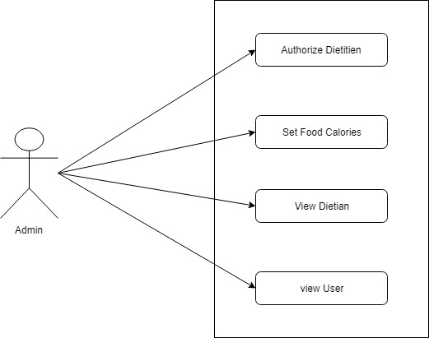

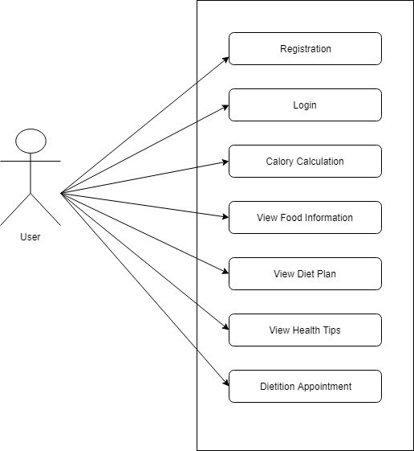

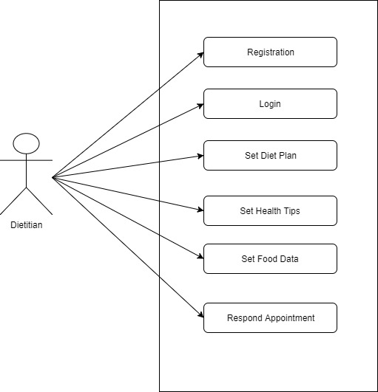

**Table Design**

*User_login*

|  |  |  |  |
| --- | --- | --- | --- |
| Field Name | Type | Constrain | Description |
| Uid | Int | Primary | Id of the user |
| Uname | Varchar |  | Name of the user |
| Utype | Int |  | Type of the user |
| Email | Varchar |  | Email of the user |
| Password | Varchar |  | Password of the user |

*User_details*

|  |  |  |  |
| --- | --- | --- | --- |
| Field Name | Type | Constrain | Description |
| User_id | Int | Primary | Id of the user |
| Uid | Int | Foreign | Id from user_login |
| Weight | Int |  | Weight of the user |
| Height | Int |  | Height of the user |
| Age | Date |  | Age of the user |
| Bmi | Number |  | BMI of the user |
| Target_weight | Number |  | Target weight to be reduced |
| Target_day | Number |  | Target day to achieve weight |
| Daily_calorie | Int |  | Calorie to consume daily |

*User_calories*

|  |  |  |  |
| --- | --- | --- | --- |
| Field Name | Type | Constrain | Description |
| cid | Int | Primary | Id of the user calorie |
| User_id | Int | Foreign | Id from user_detail |
| Date | Date |  | Todays date |
| Calorie | Int |  | Total calorie |

*Dietitian_detail*

|  |  |  |  |
| --- | --- | --- | --- |
| Field Name | Type | Constrain | Description |
| Did | Int | Primary | Id of the dietitian |
| Uid | Int | Foreign | Id from user_login |
| Dprof | Varchar |  | Profession of the user |
| Dage | Date |  | Age of the dietitan |
| Dexp | Int |  | Experience of the dietitian |
| Dcert | Image |  | To prove his profession |
| Dapprove | Int |  | Whether approved by admin |
| Dlocation | Varchar |  | Location of dietitian |
| Dcnslt | Int |  | Available for consultation |
| Drating | Int |  | Rating by user |
| Descript | Varchar |  | Description of dietitian |

*Food_info*

|  |  |  |  |
| --- | --- | --- | --- |
| Field Name | Type | Constrain | Description |
| Fid | Int | Primary | Food id |
| Did | Int | Foreign | Dietitian entered |
| Fname | Varchar |  | Name of food |
| Fcalorie | Int |  | Calorie of food |

*Diet_course*

|  |  |  |  |
| --- | --- | --- | --- |
| Field Name | Type | Constrain | Description |
| Dcid | Int | Primary | Id of the course |
| Did | Int | Foreign | Id of dietitian |
| Dctips | Varchar |  | Tips |
| Dcdocs | Varchar |  | Documents on health |
| Dvideo | Varchar |  | Video materials |
| Drating | Varchar |  | Rating by user |